Bridge Survey Field Guide with RIMS
- Download Colorado map for offline use
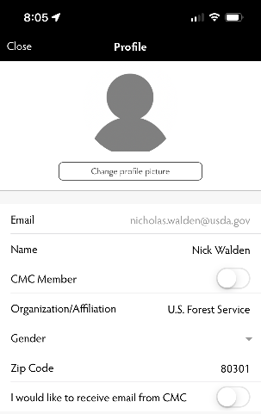
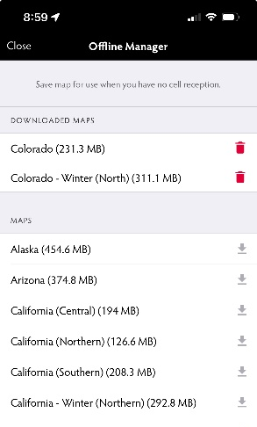

- Create Assessment with the “+” icon. Always select “Trail/Road Assessment”
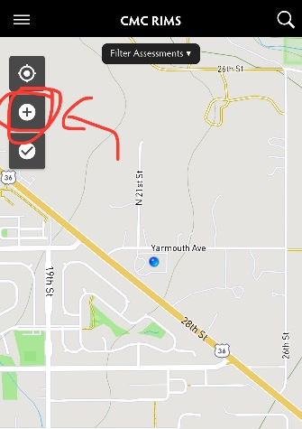
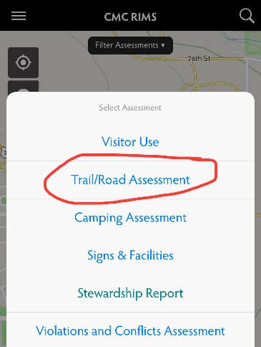

- Enter in Trail Name (and number if you know it).
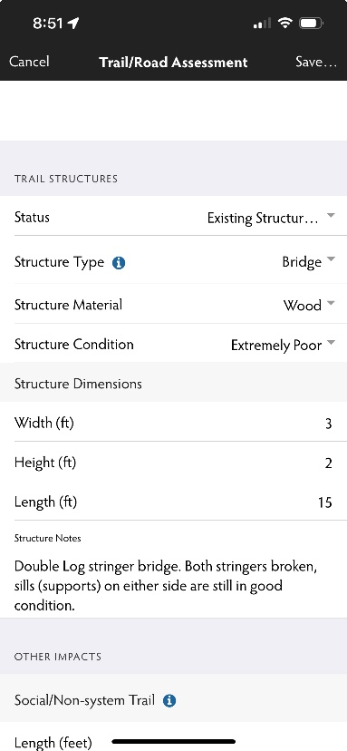
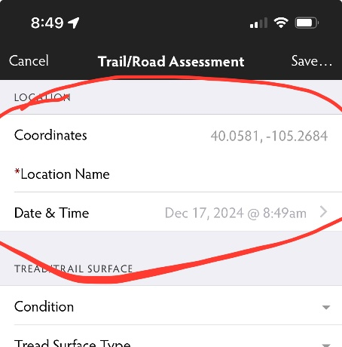
- Scroll down to the trail structures section and enter all the information about the bridge.
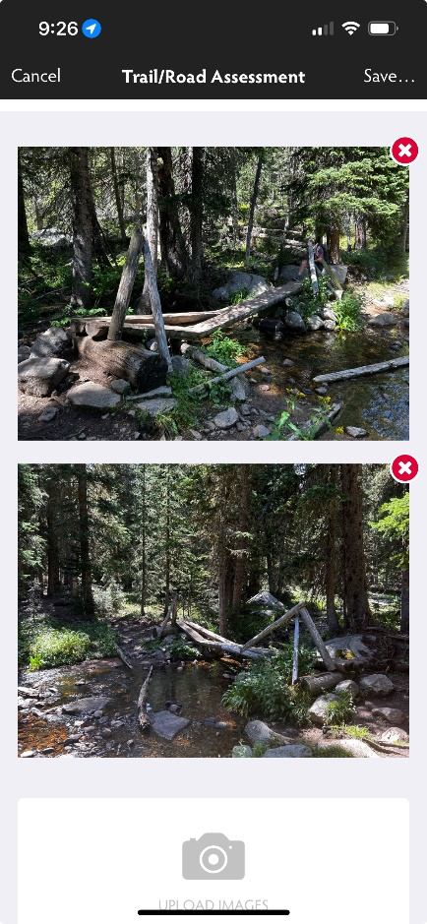
- Scroll to the bottom and ADD PHOTOS! Take photo in the app or select the picture from your photo library. Once added it will show on the assessment screen. Multiple photos from different angles are highly recommended!
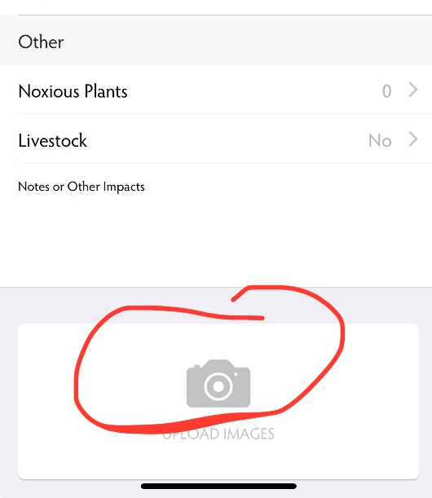
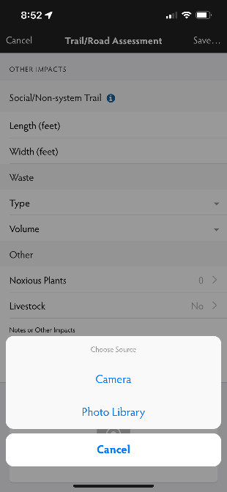

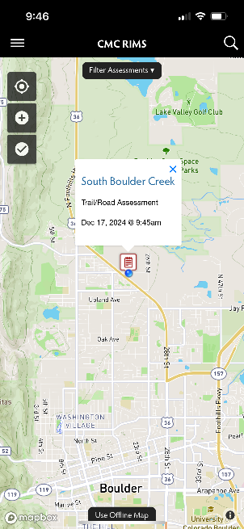
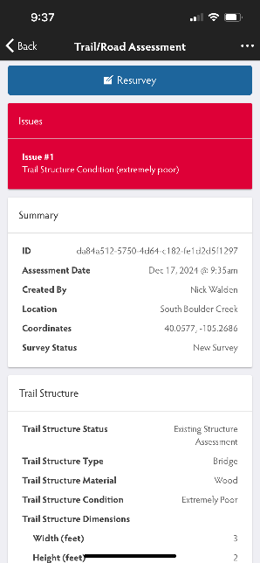
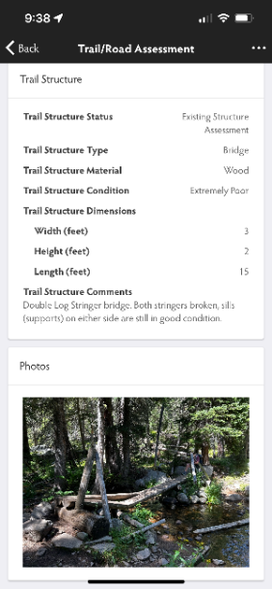
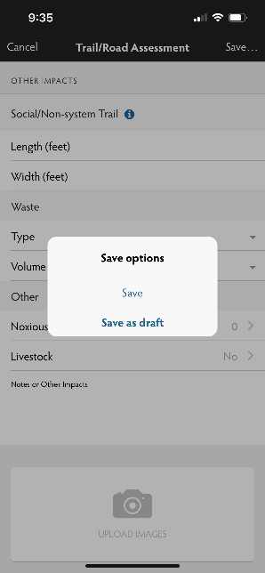
- Save assessment. Once back in service the assessment will finish uploading and you will be able to view it from the map. Make sure it uploads! If there is an orange “syncing” symbol below the checkmark button on the main map screen, it means it has not uploaded yet. Click on the orange sync button and follow the prompts to finish uploading the assessment.

Contact Nick Walden nicholas.walden@usda.gov or Lyle Skaar lyle.skaar@usda.gov with any questions.

